Physics lab report (Free Fall)

Student’s Name

Institution of Affiliation

Professors’ Name

Date of submission

Research Question
Which patterns create a steady rhythm and what does that mean for free fall? What type of motion is free fall?

Diagram
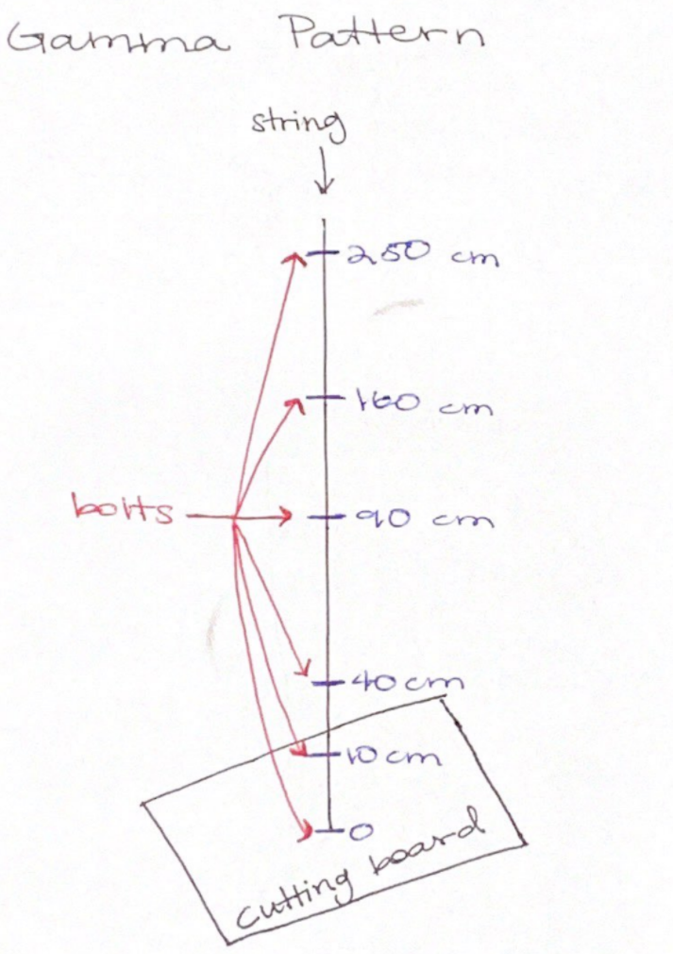

Data Collection
The screws were placed on a string at 0, 10, 40, 90, 160, 250 centimeters apart from each other to make the gamma patterns. Notice, for the beta patterns, the distance between them are evenly spaced, and for the alpha patterns, there is no specific pattern between them (see Appendix C Interval Diagram for patterns used). The following string is measured to be 3m long, afterwards the distance between them was marked in order to tie the screws at each given position. Before the drop, the string must be placed vertically straight to ensure the screws were hitting the cutting board, during the drop it was recorded using a slow motion recording device, we observed that the gamma string produced a consistent beat, however for the alpha pattern, it created a slow beat and as for the beta pattern, it had a rapid beat.

Analysis
A beat can be used as a unit of measurement given the fact that the equation of the relationship between the two parameters is known. The equation y = 10 x² can be used to given any value of y given x; thus a beat is used as a unit of measurement. The position-beat relationship is used to give the velocity that is used for plotting graph 2.

The graph of the position (x) against the beats (b) is symmetrical about the y-axis. It reflects how the beats decrease variably with an increase in beats and then starts increasing from the origin. This line (y = 10 x²) gives the position for any given beat in cm and it is used to give the velocity and the acceleration as illustrated in the time interval diagram in the appendix section. The structure of the position versus beats tells us about the time interval variations as to whether they are uniformly varying or non-uniformly varying. In this case, from the observation of the graph we conclude that the time intervals vary uniformly.

Graph 2 gives the velocity against beats as a straight line. The graph portrays the uniformity in variation of the velocity and the beats. Velocity increases as the number of beats increase. The line of best fit shows that the variation is uniform. The velocity was obtained from the below equation; which best gives the reason of the relationship and tell about the consistence of the time intervals.
Velocity = $\frac{position (cm)}{beats}$
From the time interval diagram and the velocity against beats’ graph, it was observed that:
- The gamma pattern has a constant acceleration and constant beat
- The better pattern has a constant acceleration and a constant velocity.
- The alpha pattern has a decreasing acceleration and a slowing down beat.
This is seen in the time intervals presented in the appendix C. The beta pattern has the fewest steps (2), gamma has three steps while the alpha pattern has four steps. The beta pattern could have created a steady rhythm if there were no variations in the time intervals. Could the beta pattern have had a steady rhythm, we could conclude that freefall has constant acceleration. Evenly spaced string could depict constant velocity hence zero acceleration could have been realized.
The alpha pattern has four steps with the position, velocity, acceleration and the jerk. The rhythm is not steady but could it have been, we could conclude that freefall occurs with a decreasing acceleration. The beat in the alpha pattern is slowing down with time and consequentially the speed. The acceleration is seen to decrease with time.
Appendix
Appendix A:
Position vs. Beats Graph
Line of best fit: y = 10x² or x = 10b²
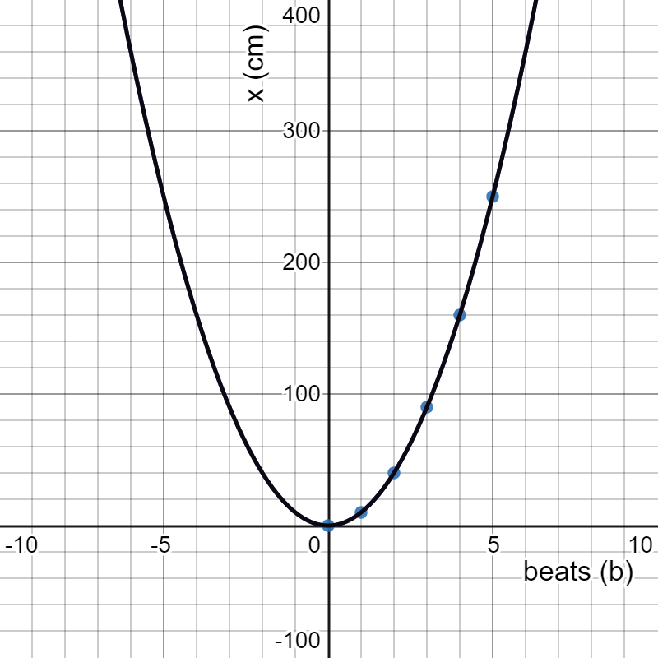

Data Table 1:
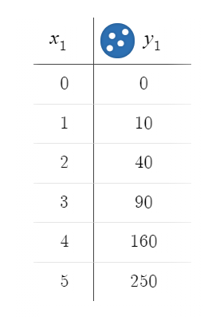

Appendix B:
Velocity vs. Beats Graph
Line of best fit: y = 20x -10 or x = 20b - 10
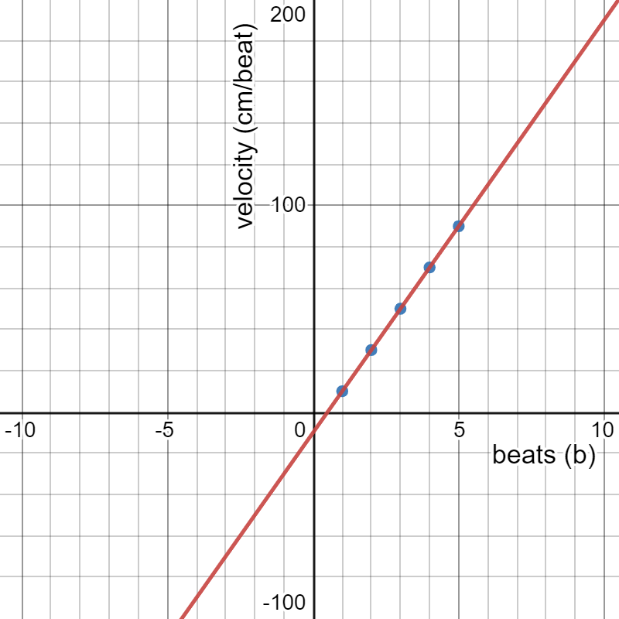

Data Table 2:
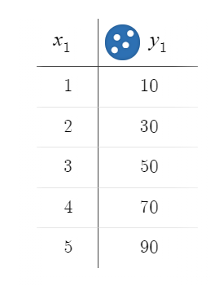
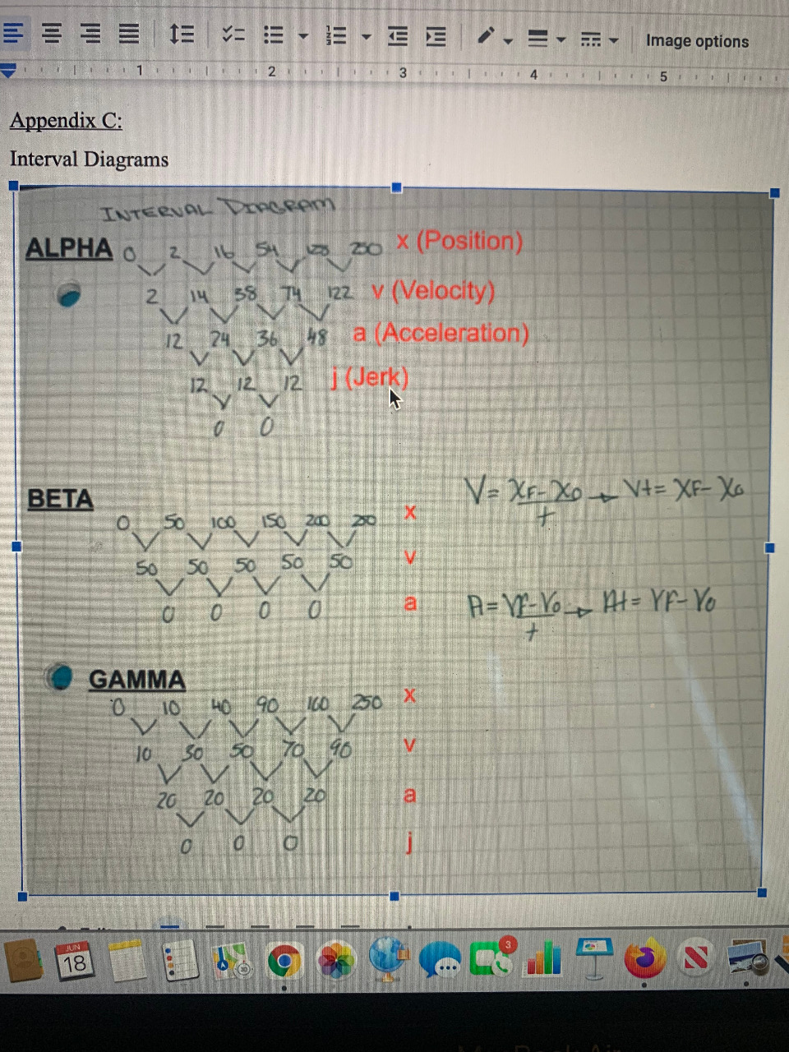
Sample calculation for the first point in Graph 2:
average velocity = xt=10 cm - 0 cm1 beat=10 cm/beat

Appendix C:
Interval Diagrams

